
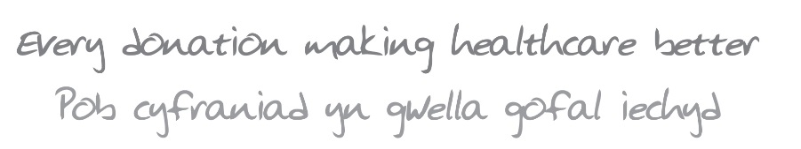
Name:
Home address:
UHB workplace (if applicable):
Phone number:
Email address:
Department/Ward/Cause to benefit from fundraising:

I require a: | men’s t-shirt |  | women’s t-shirt
In size: | XXL | XL | L | M | S

I confirm that I have spoken to my GP and received confirmation that there is no reason why I should not participate in the Cardiff Bay 10k 2020

I agree to raise a minimum in £100 for the Health Charity in return for my free running space.

I understand that Cardiff & Vale Health Charity and Cardiff and Vale UHB shall not be liable for any injury or illness caused to me or any loss or damage to my property whilst undertaking this initiative
I agree that photos taken of me whilst at the Cardiff Bay 10K event may be used to promote physical activity and fundraising in this or later years
In the event that I will not use my designated Cardiff Bay 10K 2020 place, I agree to notify the Health Charity as early as possible, and if the Health Charity is unable to reallocate my place, to reimburse the Health Charity the sum of £26
I agree to the Health Charity storing my personal information contained in this form, and using it only for administrative purposes related to the Cardiff Bay 10K 2020.
*The Health Charity will not sell or share your personal information with any third parties, ever.

Signed: Dated:
Thank you for joining #TeamHealthCharity!

We will contact you shortly with details of how to register your designated space with Run4Wales.

In the meantime, good luck with all your training! Please visit our facebook page /www.facebook.com/HealthCharity/ to share your training session updates with us, and for dates and times of our open training sessions.

Please contact Daniel Howorth on 02921836042 or fundraising.cav@wales.nhs.uk for any help or queries. Return a signed copy of this form to Daniel Howorth at fundraising.cav@wales.nhs.uk, or by post to:
Cardiff & Vale Health Charity, Woodland House, Maes-y-coed Road, Heath, Cardiff, CF14 4HH

