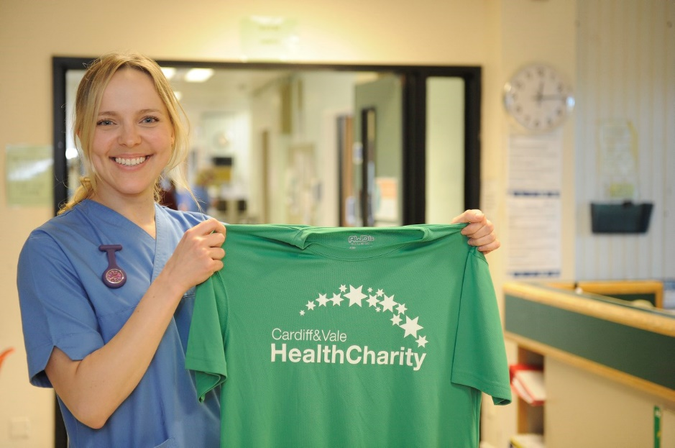

Volunteer Ambassador Role
Cardiff & Vale Health Charity is the official charity of Cardiff and Vale University Health Board. The Health Charity manages more than 300 individual ward and area funds for equipment, research, treatment and patient care. Donations support work and projects that are over and above NHS funding.
Volunteer Ambassadors help to raise awareness of the Health Charity by attending events to talk about our work and encourage others to get involved in fundraising activity. This is a really important role as it helps us to reach new people, inspire new fundraising activity and thank our supporters for the work they are doing.
Role description
- Attending events, for example community/social group meetings and cheque presentations to give presentations/talk about the work of the Health Charity and explain the difference we are making, to inspire people to support us through fundraising, or to thank supporters for the fundraising they have completed
- Representing the Health Charity in a professional manner
- Making conversation with members of the public as appropriate, and answering questions about the charity
- Promoting planned fundraising initiatives and activities
- Acting as a community advocate for the Health Charity
The benefits to you
- Experience working with a professional organisation
- A sense of satisfaction and pride for helping to make a valuable difference
- Develop your skills
- References for future employers
- Meet new people
Skills, experiences and qualities
- Personable, enthusiastic and approachable
- Initiative
- Confident in public speaking
What you can expect from the Health Charity
- An induction session to introduce you to the charity, recognise your skills and identify any ongoing support you may need from us in order to fulfil the role
- A designated point of contact for support and guidance, when needed
- Reimbursement of out-of-pocket expenses, for example travelling to and from the fundraising venue
Time commitment
This is a flexible role to suit your availability, and as such there is no minimum time commitment. Volunteer Ambassadors will be contacted as appropriate and offered the opportunity to attend events to which we are invited.
Recruitment process
Send an email to fundraising.cav@wales.nhs.uk to express your interest in the role. We’ll arrange an informal meeting to discuss this with you, before obtaining references. Following this we’ll invite you to a short induction.

