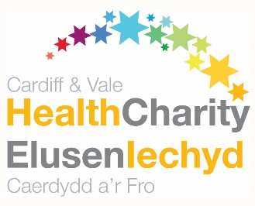
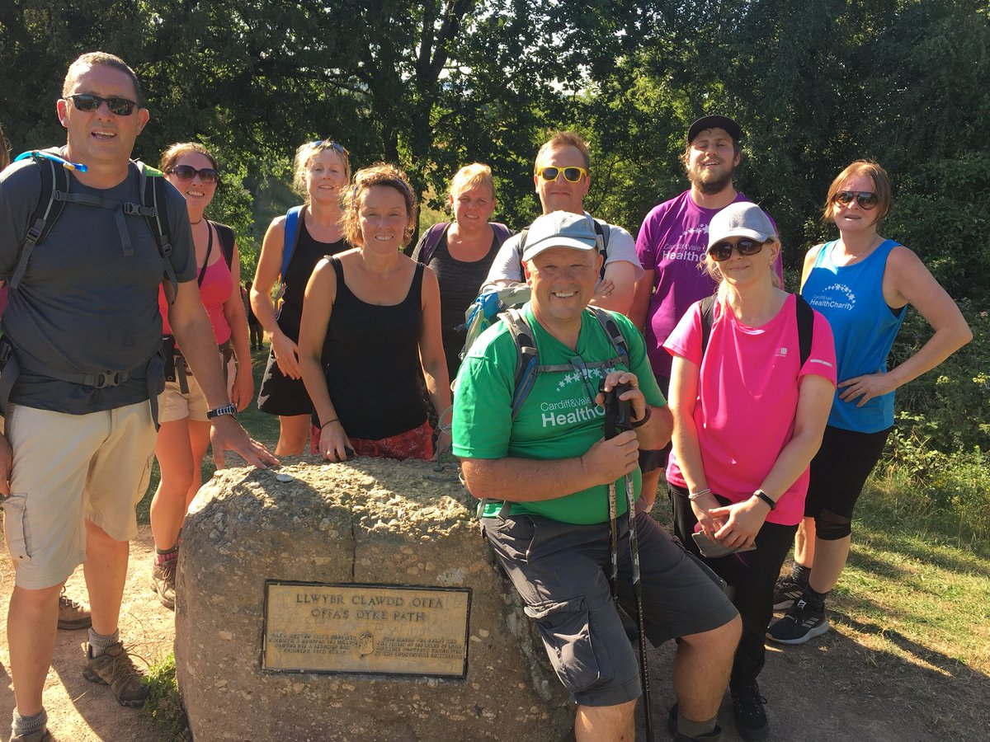

Executive Ambassador Role
Cardiff & Vale Health Charity is the official charity of Cardiff and Vale University Health Board. The Health Charity manages more than 300 individual ward and area funds for equipment, research, treatment and patient care. Donations support work and projects that are over and above NHS funding.
Executive Ambassadors help to raise awareness of the Health Charity by attending events to support our work and encourage others to get involved in fundraising activity. This is a really important role as it helps us to reach new people, inspire new fundraising activity and thank our supporters for the work they are doing.
Role description
- Attending events, for example community/social group meetings, school assemblies, and cheque presentations, to inspire people to support us through fundraising, or to thank supporters for the fundraising they have completed
- Representing the Health Charity in a professional manner
- Making conversation with members of the public as appropriate, and answering questions about the charity
- Promoting planned fundraising initiatives and activities
The benefits to you
- A sense of satisfaction and pride for helping to make a valuable difference
- Meet new people
Skills, experiences and qualities
- Personable, enthusiastic and approachable
- Initiative
- Confident in public speaking
What you can expect from the Health Charity
- An induction session to introduce you to the Health Charity
- A designated point of contact for support and guidance, when needed
Time commitment
This is a flexible role to suit your availability, and as such there is no minimum time commitment. Executive Ambassadors will be contacted as appropriate and offered the opportunity to attend events to which we are invited.

