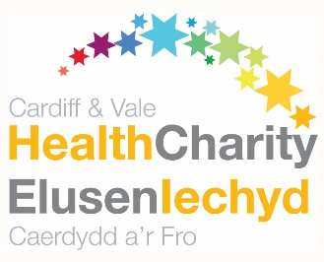
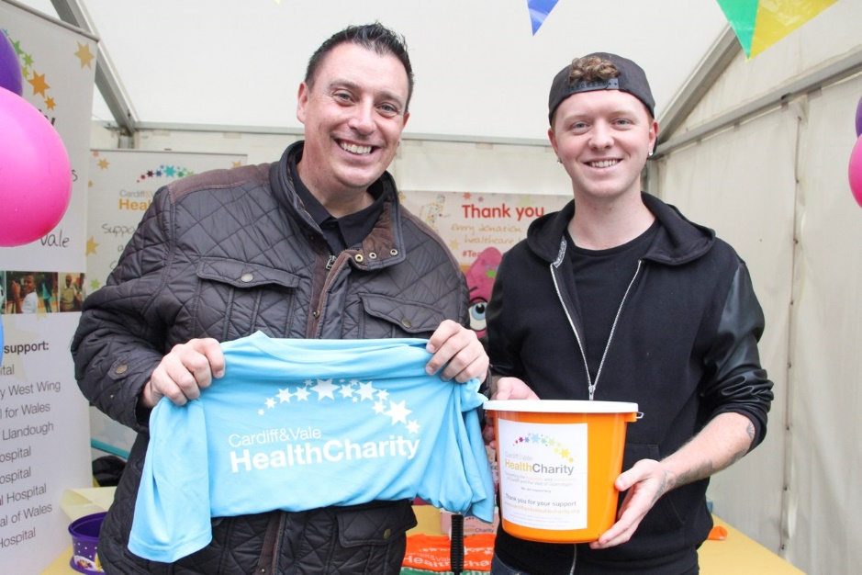

Celebrity Ambassador Role
Cardiff & Vale Health Charity is the official charity of Cardiff and Vale University Health Board. The Health Charity manages more than 300 individual ward and area funds for equipment, research, treatment and patient care. Donations support work and projects that are over and above NHS funding.
Celebrity Ambassadors help to raise awareness of the Health Charity. This is a really important role as it helps us to reach new people, inspire new fundraising activity and thank our supporters for the work they are doing.
As a Celebrity Ambassador you can choose an appeal to support.
Our appeals are:
- The Breast Centre
- The Make it Better Fund
- The Better Life Appeal
- The PROP Appeal
- Our Orchard
Role description
- Retweeting/sharing social media posts from the Health Charity
- Sending video messages of support to our Health Charity
- Attend one event per year
- Help promoting planned fundraising initiatives and activities through media
- Thank volunteers and fundraisers for helping us
The benefits to you
- A sense of satisfaction and pride for helping to make a valuable difference
- Raising your charitable giving profile through Health Charity association
What you can expect from the Health Charity
- An induction session to introduce you to the charity, tour of facilities, opportunities to meet staff
- A designated point of contact for support and guidance, when needed
Time commitment
This is a flexible role to suit your availability, and as such there is no minimum time commitment. Celebrity Ambassadors will be contacted as appropriate and offered the opportunity to attend events to which we are invited.
Want to get involved?
Send an email to fundraising.cav@wales.nhs.uk or call 02921 841801 to express your interest in the role. We’ll arrange an informal meeting/chat to discuss this with you.

